PowerMatcher i3

PowerMatcher Protocol

Authors: Aldo Eisma (IBM)



Version: 0.5
Revision: 2
Date: 14-7-2012



Table of Contents
1. Introduction 5
1.1 Identification 5
1.2 Background 5
1.3 Purpose and scope 5
1.4 Intended Audience 5
2. PowerMatcher Protocol Concepts 5
2.1.1 PowerMatcher concepts 5
2.1.2 Protocol stack 7
3. PowerMatcher Protocol Specification 9
3.1 Application level protocol 9
3.1.1 Normal interaction 10
3.1.2 Addressing 10
3.1.3 Initiation and termination 10
3.1.4 Fallback and recovery 11
3.1.5 Error handling 11
3.1.6 Timing constraints 11
3.1.7 Security 11
3.2 Broadband Messaging Protocol (INTERNAL_v1) 11
3.2.1 Messages and message format 11
3.2.2 Message sequences 13
3.2.3 Addressing 13
3.2.4 Market basis mapping 13
3.2.5 Initiation and termination 13
3.2.6 Fallback and recovery 13
3.2.7 Error handling 13
3.2.8 Timing constraints 14
3.2.9 Security 14
3.3 Narrowband Messaging Protocol (HAN_rev6) 14
3.3.1 Messages and message format 14
3.3.2 Message sequences 15
3.3.3 Addressing 15
3.3.4 Market basis mapping 15
3.3.5 Initiation and termination 16
3.3.6 Fallback and recovery 16
3.3.7 Error handling 16
3.3.8 Timing constraints 16
3.3.9 Security 16
3.4 Messaging Transport (MQ Telemetry Transport) 16
3.4.1 Client ID 16
3.4.2 Topic namespace 17
3.4.3 Wire format 17
3.4.4 Initiation and termination 17
3.4.5 Fallback and recovery 17
3.4.6 Error handling 18
3.4.7 Timing Constraints 18
3.4.8 Security 18
4. References 19

Figures
Figure 1 - Price, price step and NPU example 6
Figure 2 - Bid line curve example 7
Figure 3 - Protocol stack 7
Figure 4 - MQ Telemetry Transport 8
Figure 5 – Application Layer message sequence 10
Tables
Table 1 - Market basis attributes 6
Table 2 - Price Info message (INTERNAL_v1) 12
Table 3 - Bid message (INTERNAL_v1) 13
Table 4 - Price Info message (HAN_rev6) 14
Table 5 - Bid message (HAN_rev6) 15
Table 6 - Market basis mapping (HAN_rev6) 16

Version History

Revision | Description | Author
1 | Initial (incomplete) draft. | A.H. Eisma (IBM)
2 | Completed draft. | A.H. Eisma (IBM)

Introduction

Identification
The full identification of this document is: “PowerMatcher i3 - PowerMatcher Protocol ”, ref. TODO.

Within the PowerMatcher Reference Implementation programme this document may be referenced as [TODO].

Background
PowerMatcher i3 (instrumented, interconnected and intelligent) is the initial component-based implementation in Java of the PowerMatcher concept, as an intermediate step between the original PowerMatcher 3 implementation in .net by ECN towards a reference implementation of PowerMatcher in Java for the Flexible Power Alliance.

The PowerMatcher protocols implemented in PowerMatcher i3 is a new, message based, protocol that is different from the web services protocol implemented in the original PowerMatcher implementation. The PowerMatcher protocols in PowerMatcher i3 will be further developed towards a broadband and a narrowband protocol that will be the standard for the reference implementation.

Purpose and scope
This document contains the specification for the wideband and narrowband protocol, as well as the application level protocol, as implemented in the version 0.5 release of PowerMatcher i3. The specification defines application level protocol, wideband and narrowband messaging protocol and transport via the MQ Telemetry Transport publish-subscribe connectivity protocol.

This specification is intended to be implementation independent.

It has been implemented in the version 0.5 release of the PowerMatcher i3 Java implementation, and is used for the implementation of device agents in C and .NET for pilot projects. This specification is the starting point for the definition of the standard protocol for the new reference implementation of PowerMatcher.

Intended Audience
This technical specification is intended for development and implementation of PowerMatcher runtime environments like PowerMatcher i3 and for the developing the definition of the future standard protocol.

PowerMatcher Protocol Concepts

PowerMatcher concepts
The following PowerMatcher concepts are the basis for the protocol specification.

Market basis,
In PowerMatcher i3, the market basis is defined by the following attributes:

Attribute | Type | Description
market basis reference | unsigned integer | Sequence number for the market basis, starting at 0. The sequence number may wrap between 0 and an arbitrary maximum value 2 ^ n -1, with a minimum of 2 ^ 8 -1 = 255.
commodity | string | Commodity for the market basis, for example "electricity".
currency | string | 3 character ISO-4217 standard representation of the currency for the market basis, for example “EUR”.
minimum price | floating point | Minimum price for the market price.
maximum price | floating point | Maximum price for the market price.
price steps | unsigned integer > 0 | The number of price steps between minimum and maximum price.
significance | unsigned integer | The number of significant digits in the market price, 0 = undefined.
Table 1 - Market basis attributes
The minimum price is counted as the first price step, the maximum price as the last. So, for example:
- Minimum price = € -0.20
- Maximum price = € 0.50
- Price step = € 0.10, number of steps is 8

Price, normalized price unit and price step
The cluster price is normally expressed as a floating point value, but can also be expressed using a step index relative to the market basis. The price can be expressed as index in two alternative ways.

- As price step, starting at index 0 for the minimum price.
- As normalized price unit, with an index of 0 for the price closest to 0.0

This is shown in the following example.
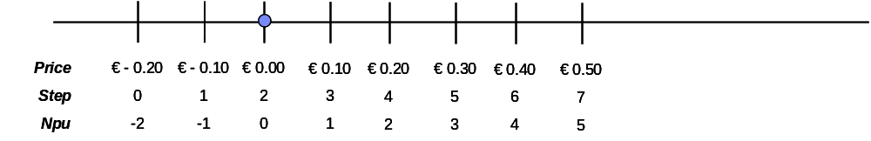
Figure 1 - Price, price step and NPU example

Bid
A bid specifies the positive or negative demand over a price range, in a decreasing bid curve.
There are two ways to express bids in PowerMatcher i3.

- The demand as vector with floating point value for each price step between minimum and maximum price as defined by the market basis.
- As a line curve define by price points connected with straight line segments.

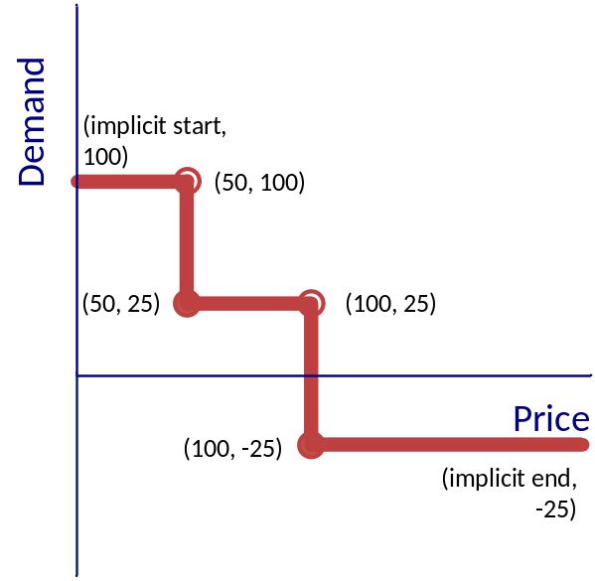
Figure 2 - Bid line curve example
The above example a bid curve is show that defines a bid curve with 2 price steps defined by 4 points:
price[0] = 50
demand[0] = 100
price[1] = 50
demand[1] = 25
price[2] = 100
demand[2] = 25
price[3] = 100
demand[3] = -25

- Note that price 50 and price 100 are used twice to define a price step using line curve semantics.
- The demand at price >= 100 is -25.
- The demand at price < 50 is +100.

Note that a flat bid curve can be represented by a single demand point where the price is any value in the range of the market basis.

The line curve representation can be converted to a vector representation and back. The conversion is lossless and is performed according to the following rules.
- From curve to vector, the demand at each price step is calculated as the intersection with the price and the line segment connecting the two points around the price.
- From vector to curve, the points are calculated for the smallest number of line segments that are an exact fit through the demand points.
- Steps in the demand vector, as in Figure 2 - Bid line curve example are identified and correctly represented in the line curve in order to preserve step semantics between conversions.

In a future specification the conversion from vector to curve and vector to vector (in the case of aggregation) may be lossy, for example limited by significance or by a maximum for the number of price points.

Protocol stack
A PowerMatcher system consists of event-based software agents that communicate via asynchronous messages. To support representation independence and distribution in heterogeneous environments, the communication between agents is based on a layered model, as shown in Figure 3.
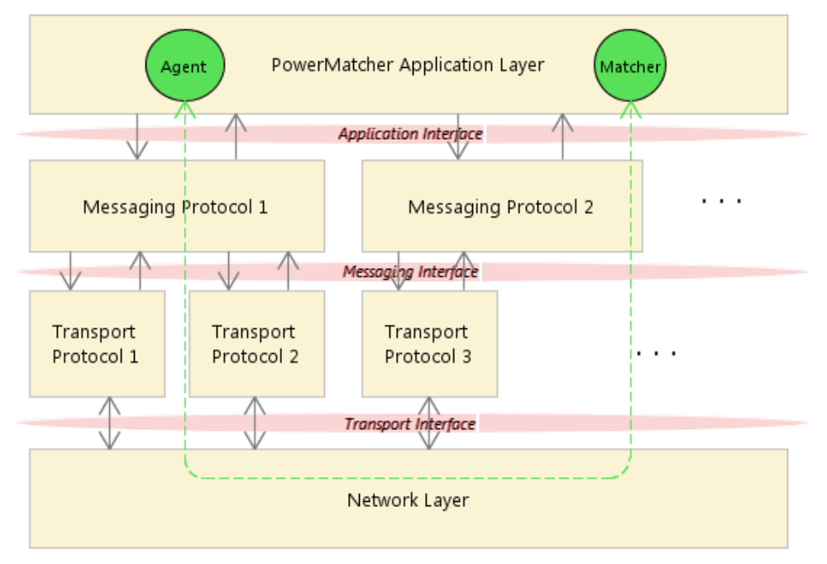
Figure 3 - Protocol stack
This figure shows the interaction between a software agent with the PowerMatcher Agent role and a software agent with the PowerMatcher Matcher role through the protocol stack.
- The Application Layer implements an Application Interface for sending and receiving PowerMatcher events in a protocol independent manner. The Application Interface is implementation dependent.
- The Messaging Layer defines a protocol and messages in a transport independent manner in the Messaging Interface. PowerMatcher i3 provides a broadband and a narrowband protocol that can be used side by side. The primary purpose of this document is the specification of the messaging protocol.
- The Transport Layer defines the connection-oriented or connectionless transport of messages between software agents. PowerMatcher i3 provides two publish-subscribe messaging transports. The transport protocol is also specified in this document.

Application level protocol
The Application Layer implements an Application Interface for sending and receiving PowerMatcher events in a protocol independent manner. The Application Interface is implementation dependent. An example is PowerMatcher i3, where the Application Interface is implemented as a Java API.
The specification of the Application Interface is not in scope for this document, but the application layer protocol is specified in general terms in the next chapter.

Broadband messaging protocol
The broadband messaging protocol in PowerMatcher i3 is a binary internal protocol. It will be replaced with the standard broadband messaging protocol once the standard has been defined. The broadband protocol is labelled “INTERNAL_v1”.

Note: a standard protocol could define multiple representations, for example binary, xml, or web services, that can be used with multiple transports.

Narrowband messaging protocol
The narrowband messaging protocol in PowerMatcher i3 is a highly optimized binary internal protocol that is based on the NXP PowerMatcher for the HAN protocol rev. 6 [2]. It will be replaced with the standard narrowband messaging protocol once the standard has been defined. The narrowband protocol is labelled “HAN_rev6”.

Transport protocol
The messaging transport supported in this release is the MQ Telemetry Transport (MQTT) publish/subscribe protocol, enabling distributed components residing on different locations with low bandwidth and processing power. The MQTT messages are transported over the TCP/IP network protocol, either in the plain for internal connections, or over SSL/TLS over the Internet. Agents connected to a MQTT broker act as MQTT-clients.

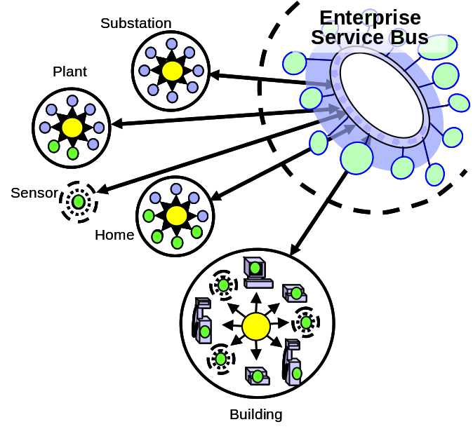
Figure 4 - MQ Telemetry Transport
MQTT is a machine-to-machine and "Internet of Things“ connectivity protocol. It was designed as an extremely lightweight publish/subscribe messaging transport by Eurotech and IBM.
- The MQTT v3 protocol is public with a royalty-free license. See reference [1].
- Various open source client and broker implementations exist.
- IBM ships commercial implementations, ranging from single device to highly scalable enterprise broker.

Currently popular languages (Java, C/C++, C#/.NET) and platforms are supported. Examples of commercial MQTT-client software implementations are:
- The redistributable Java and C clients supplied with IBM WebSphere MQ^{[4]}.
- The MQTTv5 client and Micro Broker supplied with IBM Lotus Expeditor, which provides C, Java and .NET API’s (see [3] for documentation and code samples). MicroBroker also supports bridging between distributed MQTT brokers.
- The open-source Eclipse Paho C and Java MQTTv3 client connects to, but does not include, a broker. Can connect to Mosquitto, WebSphere MQ, ...

PowerMatcher i3 supports both the MQTTv3 and the MQTTv5 protocol.

MQ Telemetry Transport v3
The MQTTv3 protocol adapter is built on the open-source Eclipse Java MQTTv3 client, and can therefore connect to MQTTv3 brokers like Mosquitto (open source) and WebSphere MQ (commercial).

MQ Telemetry Transport v5
The MQTTv5 protocol adapter is built on the IBM Java MQTTv3 client that is supplied with IBM Lotus Expeditor. It can connect to MQTTv5 brokers, which is currently only the Java MicroBroker shipped in IBM Lotus Expeditor Client software product.

There are multiple reasons for supporting MQTTv5:
- IBM Lotus Expeditor delivers an MQTTv5 .NET client, for which there is no viable open-source alternative at time of writing.
- MicroBroker provides built-in bridging functionality to other brokers over MQTTv3 and MQTTv5 to support a distributed messaging bus as shown in Figure 4.
- The MQTTv5 client supports intra-VM connections to MicroBroker broker instances running in the same Java VM, thereby avoid the TCP/IP overhead.

An MQTTv3 client can connect to an MQTTv3 and v5 broker, an MQTTv5 client can connect to an MQTTv5 broker only.

PowerMatcher Protocol Specification

Application level protocol
The application layer protocol is specified here in abstract terms, in such a way that restrictions on the message protocol layer are minimized.

The application layer protocol has the following characteristics.
- The Matcher sends updates to the PowerMatcher market basis and market price to the Agents that are below the Matcher in the PowerMatcher hierarchy. This is the normal interaction that is covered in the next section.
- The Agents sends bid updates to the first Matcher up in the hierarchy.
- A bid is always in relation to a market basis, not necessarily the latest.
- Communication is asynchronous and in any order.
- Communication can be intermittent, guaranteed delivery is not assumed.
- Addressing is the responsibility of the protocol layer.
- For the Application Layer the communication is connectionless.
- An Agent becomes aware of its Matcher as soon as it receives a market basis update.
- A Matcher becomes aware of an Agent as soon as it receives a bid update.
- Agent and Matcher forget about each other if no updates have received with some agreed upon interval.
- It is possible, that, due to limitations in the messaging protocol, the market basis is transformed between Matcher and Agent. This is allowed, but it must be transparent to the application layer.

Normal interaction
The sequence diagram of Figure 5 defines the normal asynchronous interaction between the PowerMatcher Agent and Matcher roles.

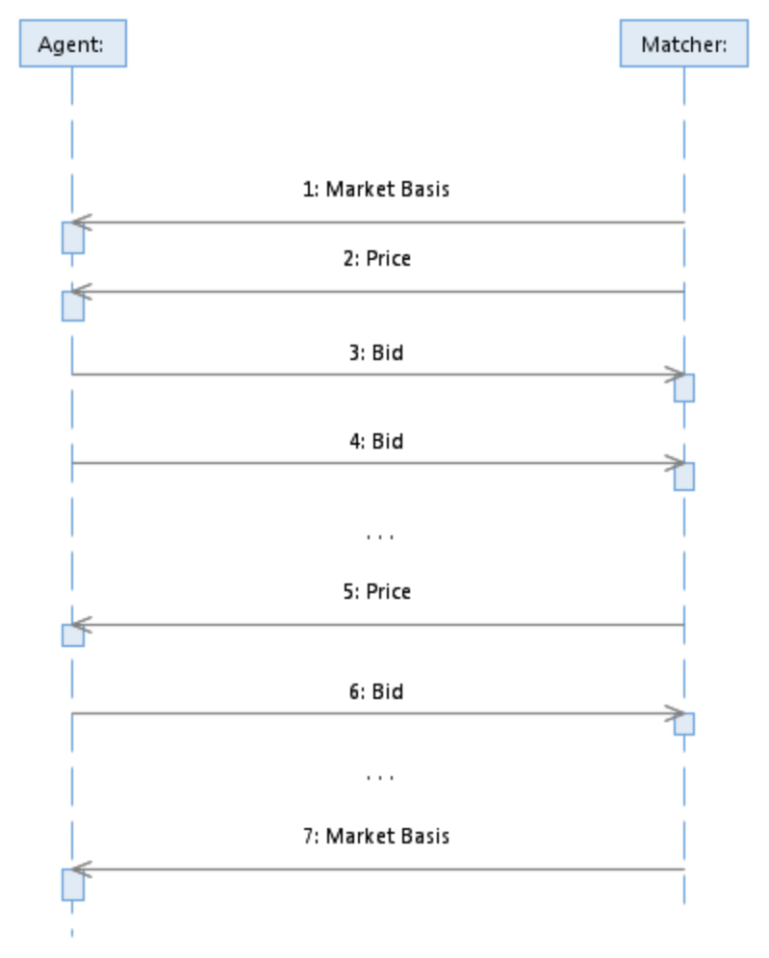
Figure 5 – Application Layer message sequence
Due to the asynchronous nature of the application layer protocol, it is possible that a Matcher receives a bid for a previous market basis. This can happen, for example, when bid and market basis updates cross one another. In this situation the Matcher transforms the bid to the current market basis.

Addressing
At application level each agent and matcher is identified by a single, simple, name, called the agent id or the matcher id.
Within a PowerMatcher cluster the agent id must be unique.
It is the responsibility of the protocol layer to separate the addressing space between PowerMatcher clusters, so that the same agent id can be used in multiple clusters.

Initiation and termination
Due to the connectionless nature of the application layer protocol, the following cases must be observed for initiation and termination:
- The Agent waits with sending its first bid until it has received a market basis from its Matcher. The Matcher broadcasts its market basis on a regular (configurable) interval, or whenever the market basis changes.
- A new Agent is known to the matcher as soon as a Matcher receives the first bid from an Agent.
- A Matcher ignores bids until it has been configured with or received its initial market basis.
- An Agent or Matcher may terminate and cease sending bids at any time.

Notes:
- Consider adding register / unregister events so that the matcher can immediately return market basis and price to the new agent. Registration may be through a null bid, as suggested in latest NXP PowerMatcher for the HAN protocol, deregistration may be implicit.

Fallback and recovery

- A Matcher discards the last bid from an Agent if the Matcher has not received an unchanged or updated bid from the Agent for some configurable interval. At this point the Agent is no longer known to the Matcher until the Matcher received a new bid from the Agent again.
- An Agent may discard the market basis and market price if the Agent has not received an unchanged or updated market basis for some (configurable) time. This has currently not been implemented in PowerMatcher i3.
Notes:
- How the Agent and Matcher should behave when they have not received an unchanged or updated market basis for some time is currently not specified.

Error handling

- When a Matcher receives a bid for an unknown market basis, the bid is ignored.
- When a Matcher receives an invalid bid, the bid is ignored. A bid is invalid when, for example, the points in the bid curve are not strictly descending. Note: this check has currently not been implemented.

Timing constraints
Messages can be sent in any sequence, at any frequency, and in any order.
Messages can be sent and received at the same time.

Security
Message integrity, authenticity, confidentiality and non-repudiation are not defined at the application layer, but may be provided by the protocol and transport and layers, if required.

Broadband Messaging Protocol (INTERNAL_v1)
The broadband messaging protocol in PowerMatcher i3 is a binary internal protocol. It will be replaced with the standard broadband messaging protocol once the standard has been defined. The broadband protocol is labelled “INTERNAL_v1”. It closely follows the definitions in 2.1.1

Messages and message format
The INTERNAL_v1 protocol defines two messages.

- Price Info message
- Bid message

Message encoding
The INTERNAL_v1 messages are variable-length binary encoded messages.
The byte order is big endian (most significant byte first).

Price Info message specification
The new market price is communicated via the Price Info message that is sent by the matcher to the connected agents. This message contains the new market price and the corresponding market basis.

The following table defines the message structure:

Field | Size in bytes | Type | Description
protocol id | 4 | unsigned integer | Magic value to identify this protocol, 0x504D494E (“PMIN “).
version | 1 | unsigned integer | Denotes the version of the protocol to which this message adheres. Version = 1 for this protocol.
msg type | 1 | unsigned integer | The message type; 1 for a Price Info message.
commodity | >= 2 | utf-8 string | Commodity of the market basis, “electricity” for electricity.
currency | >= 2 | utf-8 string | ISO-4217 standard representation of the currency for the market basis, for example “EUR”.
price steps | 2 | signed integer > 0 | Number of price steps in the market basis range
minimum price | 4 | floating point | Minimum price in the price range of the market basis.
maximum price | 4 | floating point | Maximum price in the price range of the market basis.
market reference | 1 | unsigned integer | Wrapping sequence number for the market basis.
current price | 4 | floating point | The current market price in normalized price units (npu).
Table 2 - Price Info message (INTERNAL_v1)
- An utf-8 string is encoded as a 2-byte unsigned integer specifying the length in bytes of the encoded data, followed by the Modified UTF-8 encoded data for the string.
- A 4-byte floating point value is encoded according to the IEEE 754 floating-point “single format” bit layout.

Bid message specification
The Bid message is a message from the agent to the matcher containing a bid curve, expressing the need for the electricity represented in a normalized bid price and the power demand quantity using line curve semantics (see 2.1.1.3).

The following table defines the message structure:

Field |  | Size in bytes | Type | Description
protocol id |  | 4 | unsigned integer | Magic value to identify this protocol, 0x504D494E (“PMIN “).
version |  | 1 | unsigned integer | Denotes the version of the protocol to which this message adheres. Version = 1 for this protocol.
msg type |  | 1 | unsigned integer | The message type; 2 for the Bid message.
market reference |  | 1 | unsigned integer | Reference to a market basis sequence number received in the Price Info message.
bid number |  | 4 | signed integer >= 0 | Sequence number for the bid, starting at 0. The sequence number may wrap between 0 and an arbitrary maximum value.
bid info encoding |  | 2 | signed integer > 0 | 0 = no bid; this is a keep-alive message without a bid update. In this case this field is the last field in the message.  1 = price points; the bid is represented as a line curve.  2 = demand array; the bid is represented as a demand array
price points |  |  |  | For bid info encoding = price points
 | num points | 2 | signed integer > 0 | The number of points of the bid curve, for example 2 for a bid curve that is a single step. A pair of price and power values corresponding to num points follows this field.
 | price[0] | 2 | signed integer | The price in normalized price units for the first point in the line curve.
 | demand[0] | 4 | floating point | The demand for the first point in the line curve.
 | price[1] | 2 | signed integer | The price in normalized price units for the second point in the line curve.
 | demand[1] | 4 | floating point | The demand for the second point in the line curve.
 | …
 | price[n] | 2 | signed integer | The price in normalized price units for the last point in the line curve.
 | demand[n] | 4 | floating point | The demand for the last point in the line curve.
demand array |  |  |  | For bid info encoding = demand array
 | num points | 2 | signed integer > 0 | The number of elements in the demand array. A demand value for each price step in the market basis follows this field.
 | demand[0] | 4 | floating point | The demand for the first price step.
 | …
 | demand[n] | 4 | floating point | The demand for the last price step.
Table 3 - Bid message (INTERNAL_v1)

Message sequences
The message sequence for the INTERNAL_v1 protocol is the same as the application level message sequence (see 3.1.1), except that in the INTERNAL_v1 protocol the market basis and price update are combined in a single message.

Addressing
At protocol level each agent and matcher is identified by a name pair, which is the combination of the cluster id and the agent id.
- Both cluster id and namespace id are simple identifiers.
- The agent id must be unique within the cluster.
- The cluster id must be unique within the addressing space of the messaging transport.

The cluster and agent id are not included in the Price Info and Bid message, but are exchanged as addressing information with the transport layer.

Market basis mapping
The INTERNAL_v1 protocol is compatible with the application level market basis definition, so no mapping is required.

Initiation and termination
At least one Price Info message must have been received before a Bid message can be sent, as the Bid message contains a reference to the market basis sequence number of a Price Info message. This is ensured by the application level protocol.

Fallback and recovery
There is no fallback and recovery defined at the protocol level. The communication at protocol level is stateless, with the exception of the market basis initialization.

Error handling
Invalidly encoded messages are ignored by the protocol layer. Validation of the message and message values is the responsibility of the application layer.

The protocol layer does not require guaranteed delivery or exactly-once delivery.
If this is a requirement, it is the responsibility of the transport layer.

Timing constraints
Messages can be sent in any sequence, at any frequency, and in any order.
Messages can be sent and received at the same time.
Messages between two end points must be received in the order in which they were sent.

Security
In the broadband and narrowband protocols defined in this specification message authenticity and non-repudiation are not supported at the protocol level. Message integrity and confidentiality, if required, must be provided by the transport layer.

Narrowband Messaging Protocol (HAN_rev6)
The narrowband messaging protocol in PowerMatcher i3 is a highly optimized binary internal protocol that is based on the NXP PowerMatcher for the HAN protocol rev. 6 [2]. It will be replaced with the standard narrowband messaging protocol once the standard has been defined. The narrowband protocol is labelled “HAN_rev6”.

The HAN protocol cannot represent every market basis that can be defined according to the specification in 2.1.1.

Messages and message format
The HAN_rev6 protocol defines two messages.

- Price Info message
- Bid message

Message encoding
The HAN_rev6 messages are variable-length binary encoded messages.
The byte order is big endian (most significant byte first).

Price Info message specification
The new market price is communicated via the Price Info message that is sent by the matcher to the connected agents. This message contains the new market price and the corresponding market basis.

The following table defines the message structure:

Field | Size in bytes | Type | Description
version | 1 | unsigned integer | Denotes the version of the protocol to which this message adheres. Version = 1 for this protocol.
msg type | 1 | unsigned integer | The message type; 1 for a Price Info message.
current price | 1 | signed integer | The current market price in normalized price units (npu).
market reference | 1 | unsigned integer | Wrapping sequence number for the market basis (currency, exchange rate and commodity) for this price update.
currency | 3 | ASCII characters | ISO-4217 standard representation of the currency for the market basis, for example “EUR”. Note that this is a simplification of the NXP specification which defines packed encoding of 3 characters in 2 bytes.
exchange rate | 2 | unsigned integer > 0 | npu × exchange rate / 1000 is the price in currency
commodity | 1 | unsigned integer | Commodity of the market basis, 1 = electricity.
Table 4 - Price Info message (HAN_rev6)
The maximum normalized price in the protocol is always 127. The minimum is always -127.
The number of price steps is always 255.
The maximum price that can be expressed is 127 * (2 ^16 -1) / 1000 = 8332.95.
The minimum price increment that can be expressed is maximum price / 127.

Bid message specification
The Bid message is a message from the agent to the matcher containing a bid curve, expressing the need for the electricity represented in a normalized bid price and the power demand quantity using line curve semantics (see 2.1.1.3).

The following table defines the message structure:

Field | Size in bytes | Type | Description
version | 1 | unsigned integer | Denotes the version of the protocol to which this message adheres. Version = 1 for this protocol.
msg type | 1 | unsigned integer | The message type; 2 for the Bid message.
market reference | 1 | unsigned integer | Reference to a market basis sequence number received in the Price Info message.
power unit | 2 | unsigned integer | Denotes the step size of power in Watt. For example, 1 if the unit of measure is 1 W.
num points | 1 | unsigned integer | The number of points of the bid curve, for example 2 for a bid curve that is a single step. A pair of price and power values corresponding to num points follows this field.
price[0] | 1 | signed integer | The price in normalized price units for the first point in the line curve.
demand[0] | 2 | signed integer | The demand in power units for the first point in the line curve.
price[1] | 1 | signed integer | The price in normalized price units for the second point in the line curve.
demand[1] | 2 | signed integer | The demand in power units for the second point in the line curve.
…
price[n] | 1 | signed integer | The price in normalized price units for the last point in the line curve.
demand[n] | 2 | signed integer | The demand in power units for the last point in the line curve.
Table 5 - Bid message (HAN_rev6)

Message sequences
The message sequence for the HAN_v6 protocol is the same as the application level message sequence (see 3.1.1), except that in the HAN_v6 protocol the market basis and price update are combined in a single message.

Addressing
At protocol level each agent and matcher is identified by a name pair, which is the combination of the cluster id and the agent id.
- Both cluster id and namespace id are simple identifiers.
- The agent id must be unique within the cluster.
- The cluster id must be unique within the addressing space of the messaging transport.

Market basis mapping
The HAN_v6 protocol is incompatible with the application level market basis definition.
The protocol layer maps between application level market basis and protocol layer market basis according to the following table.

HAN_v6 limitation | Mapping from application level
The price range has a limited maximum and minimum. | No mapping if limit exceeded.
Minimum and maximum of the price range always have the same absolute value. | HAN exchange rate is calculated to be > than the value needed for the maximum of application level maximum price and negated minimum price.
The number of steps in the price range is always 255. | If > 128 for the number of steps from price 0 to maximum or minimum, the application level range is scaled down to 128 steps.  If < 128 for the number of steps from price 0 to maximum or minimum, the HAN exchange rate is calculated for the same price increment as at the application level.
Table 6 - Market basis mapping (HAN_rev6)
The market basis mapping by the protocol layer is invisible to the application level.

Initiation and termination
At least one Price Info message must have been received before a Bid message can be sent, as the Bid message contains a reference to the market basis sequence number of a Price Info message. This is ensured by the application level protocol.

Fallback and recovery
There is no fallback and recovery defined at the protocol level. The communication at protocol level is stateless, with the exception of the market basis initialization.

Error handling
Invalidly encoded messages are ignored by the protocol layer. Validation of the message and message values is the responsibility of the application layer.

The protocol layer does not require guaranteed delivery or exactly-once delivery.
If this is a requirement, it is the responsibility of the transport layer.

Timing constraints
Messages can be sent in any sequence, at any frequency, and in any order.
Messages can be sent and received at the same time.
Messages between two end points must be received in the order in which they were sent.

Security
In the broadband and narrowband protocols defined in this specification message authenticity and non-repudiation are not supported at the protocol level. Message integrity and confidentiality, if required, must be provided by the transport layer.

Messaging Transport (MQ Telemetry Transport)
The messaging transport supported in this release is the MQ Telemetry publish/subscribe protocol, enabling distributed components residing on different locations with low bandwidth and processing power. The MQTT messages are transported over the TCP/IP network protocol, either in the plain for internal connections, or over SSL/TLS over the Internet. PowerMatcher Agents connected to a MQ Telemetry broker act as MQTT-clients.

This section specifies how MQTT is used as the messaging transport for both the broadband and narrowband protocol.

Client ID
Each client connection to an MQTT message broker must have a unique identifier. This identifier does not play a role in addressing in the PowerMatcher protocol and could be generated, as long as uniqueness is guaranteed and a valid client identifier (<= 23 characters from allowed character set) is used.

The recommendation, implemented in PowerMatcher i3, is to use the following concatenationas the client ID:

<id>.<clusterId>

where {id} is the simple identifier of the agent or matcher within the cluster and
{clusterId} is the simple identifier for the cluster.

Topic namespace
The publish/subscribe topic namespace for the PowerMatcher wideband and narrowband messages has the following root:

PowerMatcher/{clusterId}

where {clusterId} is the simple identifier for the cluster.
The topics for the Price Info and Bid messages are:

PowerMatcher/{clusterId}/{matcherId}/UpdatePriceInfo
PowerMatcher/{clusterId}/{matcherId}/{agentId}/UpdateBid

Where:
- {matcherId} is the identifier of the matcher that is publishing the Price Info message, or subscribing to the Bid message.
- {agentId} is the identifier of the agent that is publishing the Bid message.
- The topic suffixes are UpdatePriceInfo and UpdateBid by default, but are configurable at protocol level.

An agent subscribes to receive price updates using the following wildcard pattern:

A matcher subscribes to receive bid updates using the exact topic for the matcher it expects to receive its update from:

PowerMatcher/{clusterId}/{matcherId}/UpdateBid

Wire format
The wire format for the MQTT v3 protocol is defined in the open standard.
The MQTT protocol v5 is IBM proprietary and has not been published as open standard.

Even though MQTT v5 can be used as the PowerMatcher messaging transport, no capabilities in MQTTv5 are used that are not also supported the MQTT v3 in order to ensure compatibility. A PowerMatcher agent using the MQTTv3 protocol can exchange messages with an MQTTv5 agent without restrictions and conversion.

Initiation and termination
The MQTT connection between the client and the broker is initiated by the client. The MQTT client connection is initiated when the PowerMatcher application attempts to start the connection. If the MQTT broker is not available at this time, the connection attempt is repeated at some interval until the client connection is successful, or the application stops the connection.

The application is notified, via the protocol adapter, when the connection has been established or when the connection closed.

Optionally, the MQTT client sends a configurable notification message when the connection is established and when the connection is closed (normal close). The notification messages are intended to be used for monitoring.

Fallback and recovery

- The MQTT topic subscriptions on the message bus for the PowerMatcher transport are defined to be non-persistent. This means that the message broker will not queue messages when the connection with the MQTT client is lost.
- MQTT topics for the PowerMatcher transport are published with ‘fire-and-forget’ (QoS 0) semantics. This means that messages may get lost in transit and will not be buffered by the client when the connection with the MQTT broker is lost.
- If the connection is lost, a reconnection is attempted at some interval until the client connection has been restored, or until the application closes the connection.

Error handling

- Message integrity is guaranteed by the transport layer.
- The MQTT keep-alive option is used to monitor the liveliness of the TCP/IP connection between client and broker.
- The application is notified, via the protocol adapter, when the connection was lost or has been closed.
- Optionally, using the MQTT ‘last will and testament’ option, the MQTT client configures the MQTT broker to send a notification on the broker-end when the connection is broken (unexpected disconnect). The notification messages are intended to be used for monitoring.

Timing Constraints
Messages can be sent in any sequence, at any frequency, and in any order.
Messages can be sent and received at the same time.
Messages between two end points must be received in the order in which they were sent.

Security
The PowerMatcher MQTT transport optionally provides:
- Confidentiality for the connection between MQTT client and broker using SSL or TLS over TCP/IP, depending on the client and broker implementation and cipher suite capabilities.
- Basic authentication of the MQTT client to the MQTT broker with username and password, or anonymous connections of permitted.
- Topic-based authorization for publish and subscribe to separate PowerMatcher clusters and other applications from each other on the same bus.

The availability of security capabilities is implementation dependent. Not all MQTT clients and brokers support SSL or TLS. Not all MQTT brokers support topic-level authorization.

- References

 | MQ Telemetry Transport (MQTT) V3.1 Protocol Specification, International Business Machines Corporation (IBM), Eurotech, (see http://mqtt.org/documentation) | 2010
 | PowerMatcher for the HAN, Rev. 6, NXP; Pennings, M. | 13-07-2011
 | Lotus Expeditor Wiki : Lotus Expeditor 6.2.3 Documentation, section: “Developing an application using the MQTT API”,  http://www-10.lotus.com/ldd/lewiki.nsf/dx/Developing_an_application_using_the_MQTT_API_XPD623 | N/A
 | IBM WebSphere MQ Information Center, section: “Developing applications for WebSphere MQ Telemetry”,  http://publib.boulder.ibm.com/infocenter/wmqv7/v7r1/topic/com.ibm.mq.doc/tt60000_.htm | N/A

http://www.xe.com/iso4217.php
Significance is currently not used in the PowerMatcher i3 implementation, as the price steps attribute already constrains the precision. It could be used for printing numbers.
See http://mqtt.org for more information on the open standard MQ Telemetry protocol.
See http://en.wikipedia.org/wiki/UTF-8#Modified_UTF-8
See http://mqtt.org for more information on the open standard MQ Telemetry protocol.
See http://mqtt.org for more information on the open standard MQ Telemetry protocol.

